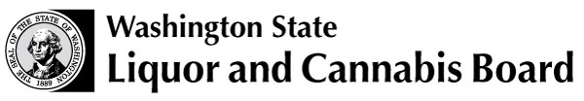 | Licensing and Regulation Division  1025 Union Ave SE  PO Box 43098  Olympia WA 98504-3098  Phone: (360) 664-1600  Fax: (360) 664-4054  www.lcb.wa.gov
  License Number
  Trade Name
  UBI Number

Wine Dispensing Machine Acknowledgement Form

I understand that in order to install and use an automated wine dispensing machine in the tasting room of my licensed winery, I must meet the following requirements:

- Wine dispensed will be wine of my own production.

- Employees participating in the wine tasting must hold a class 12 or class 13 alcohol server (MAST) permit.

- A wine tasting card must be purchased from an employee of the winery. The card may allow no more than a total of five ounces dispensed in single servings of no more than one ounce, and no more than two cards may be purchased by any one customer per day.

- Wine tasting cards will not be sold to an apparently intoxicated customer or to a person under twenty-one years of age.

- Winery employees must be present in the wine tasting areas. There must be an appropriate level of supervision to observe customers throughout the tasting area.

I certify by my signature below that I will meet and continue to maintain the above requirements as long as an automated wine dispensing machine is being utilized in my domestic winery tasting room.

Signature of Applicant (Sole Proprietor, Partner, Officer, LLC Member/Manager) |  | Date

