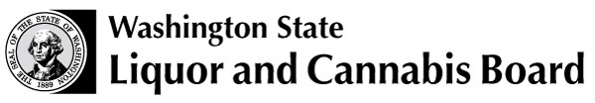 | Licensing and Regulation  PO Box 43098  Olympia WA 98504-3098  (360) 664-1600 (Press 4)  Fax: (360) 753-2710  www.lcb.wa.gov

Liquor and Cannabis Board Addendum - Club

This form must accompany a Master Application from the Department of Licensing, Master License Service.

Club licenses are issued to bona fide nonprofit organizations, with liquor sales being incidental to the main purposes of the club. The organization must have operated for at least one year immediately prior to this application.

For more information, please see the “Club Liquor License Information Sheet.”

Questions? Please call the Liquor and Cannabis Board customer service desk at (360) 664-1600 (Press 4).

Applicant Information
Name of Organization
Premises address: | Street |  | City | State | Zip Code

Organization Information
When was the organization formed?
Is this a nonprofit organization, registered with the Washington Secretary of State? |  | yes no
Secretary of State File No.
Purpose of the organization Patriotic / Fraternal Benevolent / Educational / Athletic / Social
Is the club part of a nationally chartered organization? Yes No

Officer Information
Name of Officer / Director | Title | Date of Birth | Social Security No.

Membership Information
No. of registered members: |  | No. of members under 21:
Name of Membership Classification |  | No. of Members in Classification | Initiation Fee |  | Annual Dues

Facility Information
Name of person responsible for day-to-day operations:

Home Address: |  | Street | City |  | State | Zip Code
Day Telephone No: |  |  |  | Evening Telephone No:
Check any of the following facilities your club offers its membership:

 | Cocktail Lounge Dining Room Lodge Room Golf Course Game Room
 | Athletic Facility Others
Which, if any, departments or facilities of your organization are operated on a concession basis?

Signature/Title |  | Date |  | Phone Number

